Project Design Phase-II

Data Flow Diagram & User Stories

|  |  |
| --- | --- |
| Date | 17th june 2025 |
| Team ID | LTVIP2025 TMID35397 |
| Project Name | Revolutionizing Liver Care : Predicting Liver Cirrhosis Using Advanced Machine Learning Techniques |
| Maximum Marks | 4 Marks |

**Data Flow Diagrams:**

A Data Flow Diagram (DFD) is a traditional visual representation of the information flows within a system. A neat and clear DFD can depict the right amount of the system requirement graphically. It shows how data enters and leaves the system, what changes the information, and where data is stored.

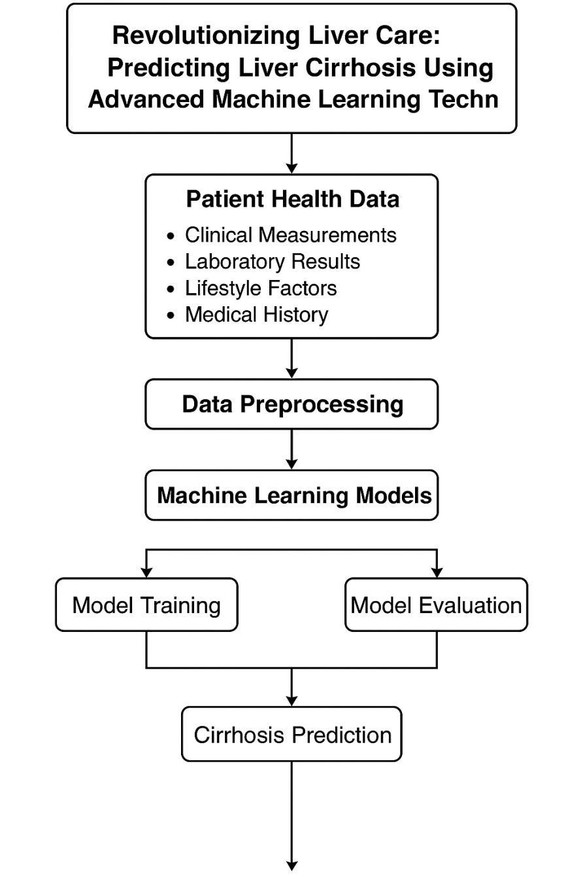

**User Stories**

|  |  |  |  |  |  |  |
| --- | --- | --- | --- | --- | --- | --- |
| **User Type** | **Functional Requirement (Epic)** | **User Story Number** | **User Story / Task** | **Acceptance criteria** | **Priority** | **Release** |
| Medical Specialist | Real-time Cirrhosis Risk Prediction | USN-1 | As a Medical Specialist, I want to access real-time liver cirrhosis risk predictions to assist in early diagnosis and clinical decisions. | System provides accurate real-time cirrhosis risk scores. Data updates with each patient input. 95% confidence level. | High | Sprint 1 |
| Patient | Health Risk Awareness | USN-2 | Application displays personalized cirrhosis risk level based on health inputs. | User sees risk level summary with explanation and next-step suggestions. | High | Sprint 1 |
| Medical Data Analyst | Data Insights on Liver Health Trends | USN-3 | As a Medical Data Analyst, I want access to trends in liver health data to support research and policy-making. | Dashboard shows trends across patients, age groups, liver enzymes, etc. | Medium | Sprint 2 |
| Web Developer | Model integration | USN-4 | As a Web Developer, I want to integrate the predictive model into an accessible health platform. | Model is accessible via API. Integration guide provided. Accurate predictions returned for given input sets. | High | Sprint 2 |
| |  | | --- | | Hospital Admin |  |  | | --- | |  | | Customizable Diagnostic Features | USN-5 | As a Hospital Admin, I want customizable features in the platform to align with clinical workflows. | Admin panel allows adjusting alert thresholds, report formats, and clinician access controls. | High | Sprint 3 |
| Medical Universities | Training | USN-6 | Implement data augmentation (e.g., synthetic patient records) to improve model robustness and provide training datasets. | we could do testing | medium | Sprint 4 |
| QA Team | Testing & quality assurance | USN-7 | Conduct end-to-end testing of model and web interface; fine-tune hyperparameters and collect user feedback for performance enhancement. | Optimized performance based on feedback. | medium | Sprint 5 |